KAAY URSD- PHASE 1

**Student Application:**

Student application allows students to use the application and access courses and other features available on the application.

Most of the functionalities will be same as Allen Plus dash board.

<https://aphelp.allenerp.com/docs/important-links/schedule/>

<https://aphelp.allenerp.com/docs/important-links/>

|  |  |  |  |
| --- | --- | --- | --- |
| **Field Name** | **Mandatory?** | **Data Type** | **Description** |
| **Student Registration** | | | |
| First Name | **Y** | Text Box | First Name of the person who is registering. |
| Last Name | **Y** | Text Box | Last Name of the person who is registering. |
| Email Address | **Y** | Text Box | Email Address |
| Phone Number | **Y** | Text Box | Phone Number with country codes. |
| Class | **Y** | Dropdown + text box + others option add text | Student can select their class from dropdown |
| Username | **Y** | Textbox | User can select their preferred username |
| Password | **Y** | Textbox | User can select their preferred password for the application |
| Confirm Password | **Y** | Textbox | User will have to re-enter the password for confirmation. |
| Social login | **N** | Icons | Users can select for social login   * Google * Fb |
| Terms and Condition | **Y** | Checkbox | Users will have to agree to T&C before proceeding further on the application. |
| Signup | **Y** | Button | User need to enter the button to submit the form |
| **OTP Verification** | | | |
| Enter OTP screen | **Y** | Input box | Users need to enter the otp send on the verified number. |
| Resend code again | **N** | Link | Allows users to resend the link to send the OTP again |
| **Login** | | | |
| Username | **Y** | Input | User need to enter their username ( mobile /email) |
| Password | **Y** | Input | Users need to enter password to login into the application |
| Login | **N** | Button | Enable users to hit the button and then login into the application. |
| Login as a guest | **N** | Hyper link | If user does not want to login into the application then can login as a guest to explore the application |
| Don’t Have an Account? Sign Up | **N** | Hyper link | If users does not have an account and are willing to sign up on the application they can signup here. |
| **Class/Boards Selections** | | | |
| Board selection | **Y** | Dropdown + text box + others option add text  (Approved by admin to add other option list in main dropdown or not) | Values : cbse  Icse  Isc  CISCE ?  Rbse |
| Class selection | **Y** | Check box | User can select their classes in the form of checkboxes. Class will be one only, example gad 1st- 4th yr, ug, pg |
| Class selection is above board selection, if condition applied, if class>12 don’t ask for board  If<=12 then ask |  |  |  |
| Next | **Y** | Button | Allows user to proceed further |
|  |  |  |  |
| **Stream Selection** | | | |
| Stream selection | **Y** | Check box | User can select their stream in the form of checkboxes. Multiple options |
| Next | **Y** | Button | Allows user to proceed further |
| **Courses Selection** | | | |
| Courses selection | **Y** | Check box | User can select their courses in the form of checkboxes. |
| Next | **Y** | Button | Allows user to proceed further |
| **Weekly Test Dashboard** | | | |
| Progress graph | **N** | Graph | User can see their avg /overall progress in graphical representation along with the latest test attempted & also compare with others data  like Allen example |
| Total test attempted | **N** | Button | Allows user redirect to screen consisting of the total test attempted along with their marks & report. |
| Upcoming test | **N** | Button | Allows users to view the upcoming test in the queue |
| Practice test | **N** | Button | Allows user to take practice test for their assessment. |

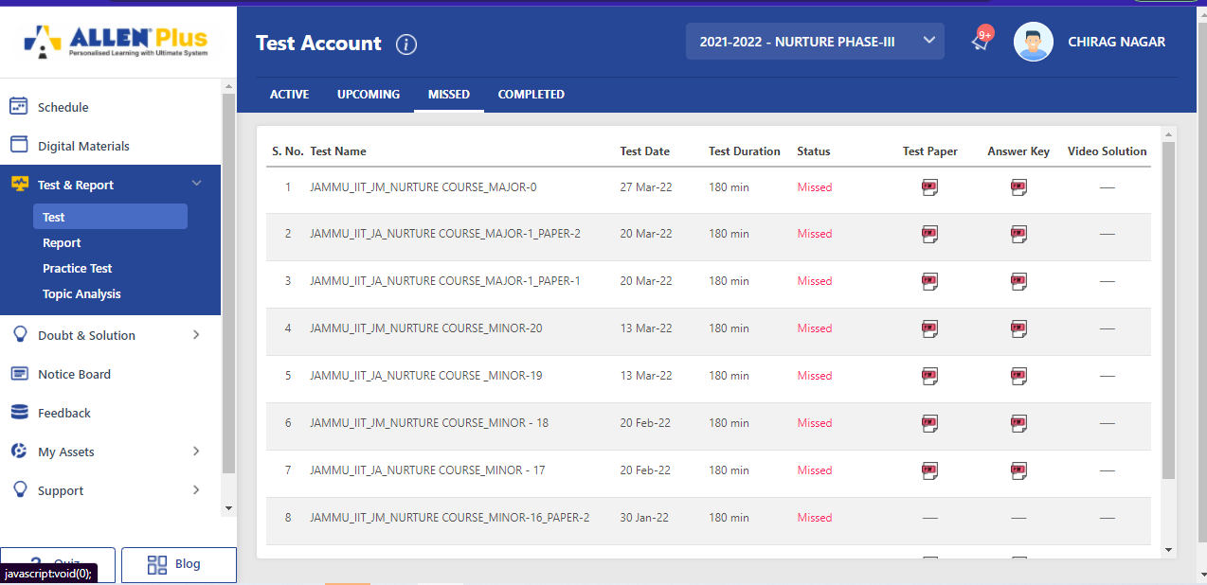

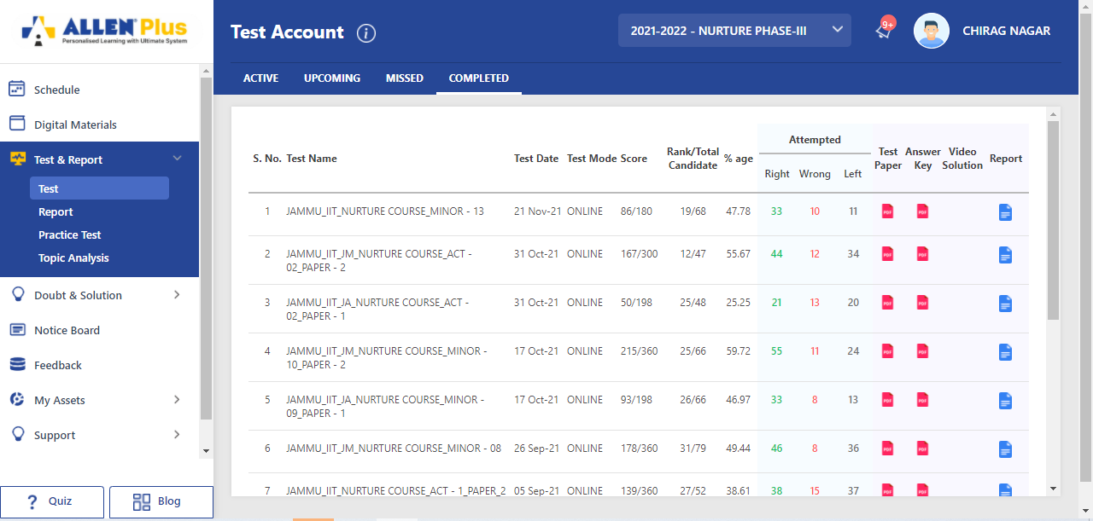

|  |  |  |  |
| --- | --- | --- | --- |
| **My Dashboard** | | | |
| **Field Name** | **Mandatory?** | **Data Type** | **Description** |
| My Subject | N | Card view | Will consist of the subject card of different subject studied by the student |
| My videos | N | Video listing  (Automatic course wise/Automatic student wise/Manual) | Will consist of list of videos subscribed by the student for a particular course |

**L**

|  |  |  |  |
| --- | --- | --- | --- |
| **My Schedule** |  |  |  |
| **Field Name** | **Mandatory?** | **Data Type** | **Description** |
| Calender |  |  |  |
| Timetable |  |  |  |
| Daily activity ask from student |  |  |  |
| Their pre occupied times |  |  |  |
| Make schedule according to student requirements |  |  |  |
| Customized time table |  |  |  |
|  |  |  |  |

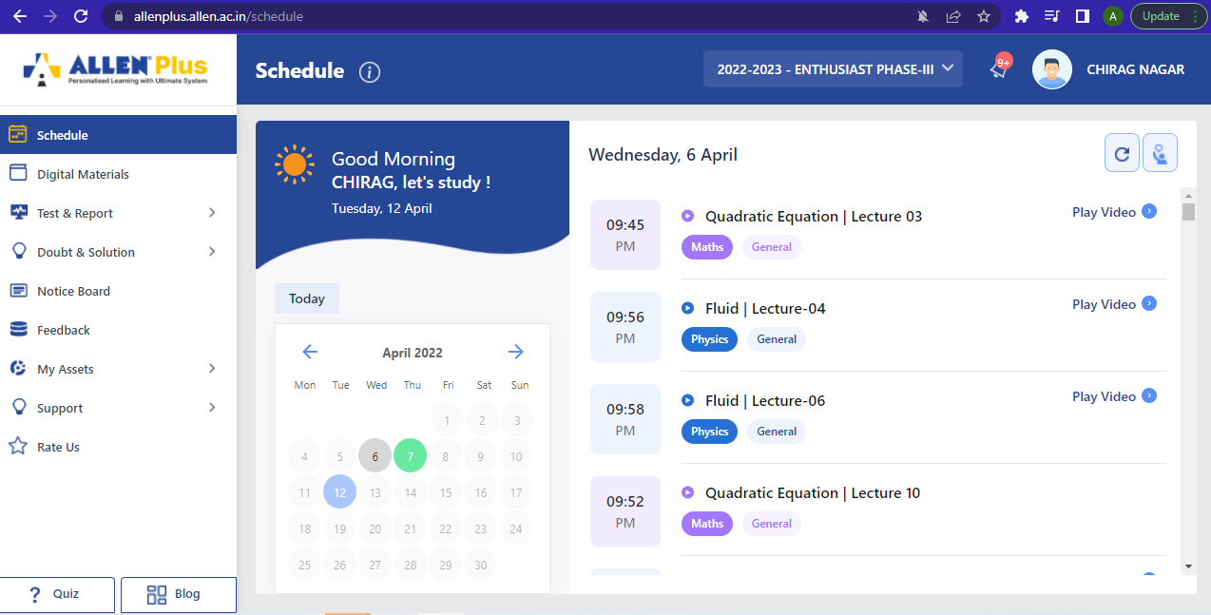

|  |  |  |  |
| --- | --- | --- | --- |
| **My Reports** | | | |
| **Performance Report** | | | |
| **Field Name** | **Mandatory?** | **Data Type** | **Description** |
| All Subject Report | N | Graph view | Will consist of the subject report in graphical form + table form, if click on graph then report pops up. |
| Total test attempted | N | Number count | Will consist of the count of total test attempted by the student irrespective of the subject. |
| Subject wise performance | N | Graph view+ | Will consist of the performance of student in a particular subject. |
| Take test ( continue test) | N | Button | Allows users to take practice test of that particular subject |
| **Progress Report** | | | |
| All Subject Report | N | Graph view | Will consist of the subject report in graphical form |
| Total test attempted | N | Number count | Will consist of the count of total test attempted by the student irrespective of the subject. |
| Subject wise progress | N | Graph view + report | Will consist of the progress of student in a particular subject. |
| Take test (continue test) | N | Button | Allows users to take practice test of that particular subject |
| Practice test |  |  |  |
| Topic analysis |  |  |  |
|  |  |  |  |

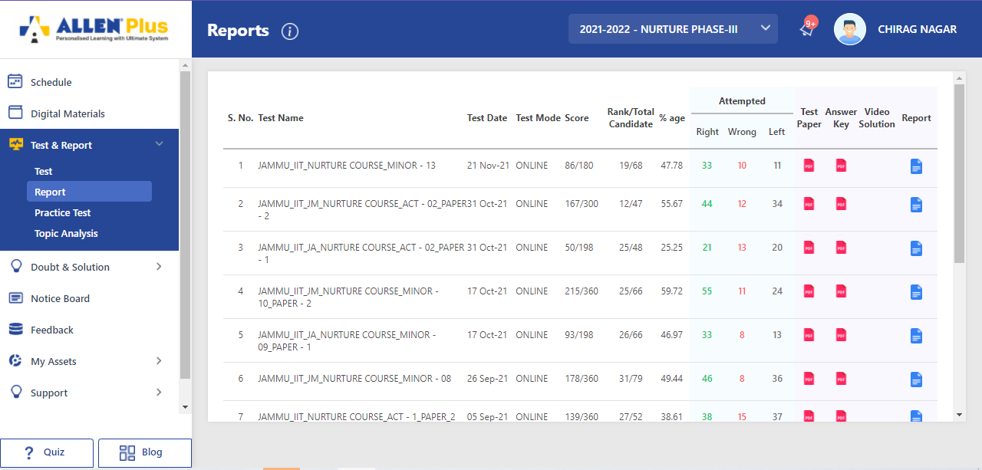

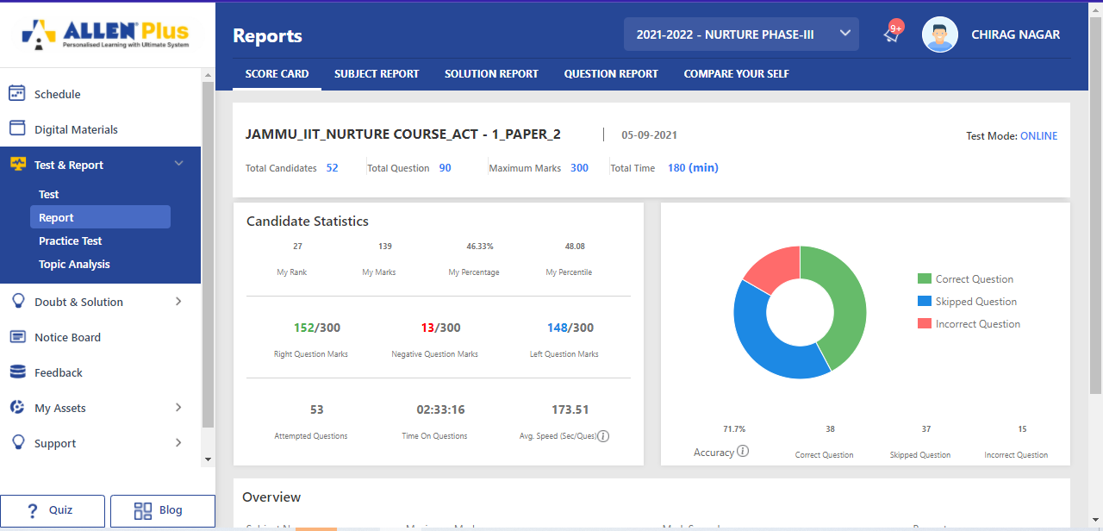

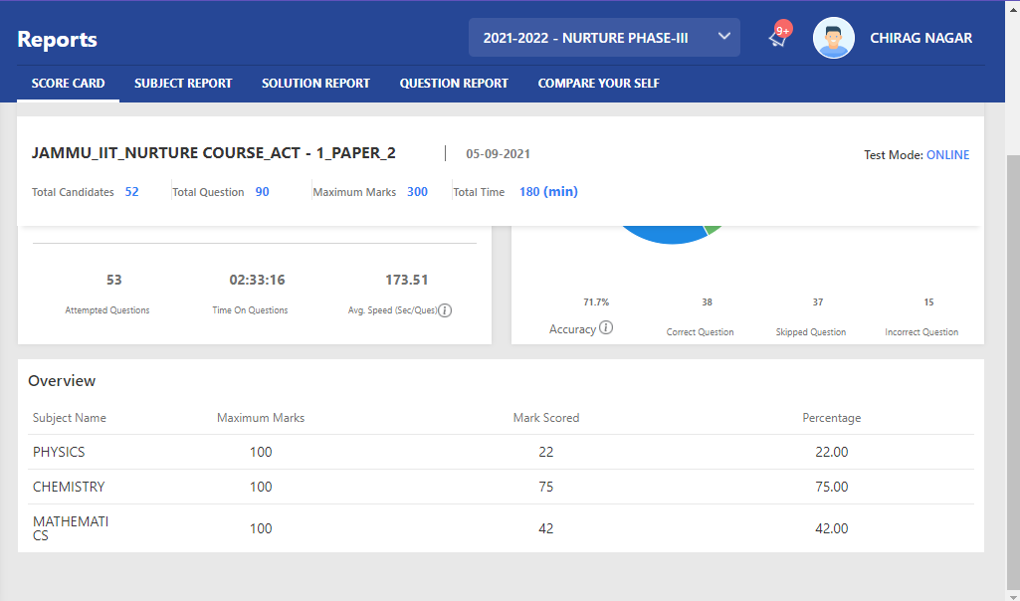

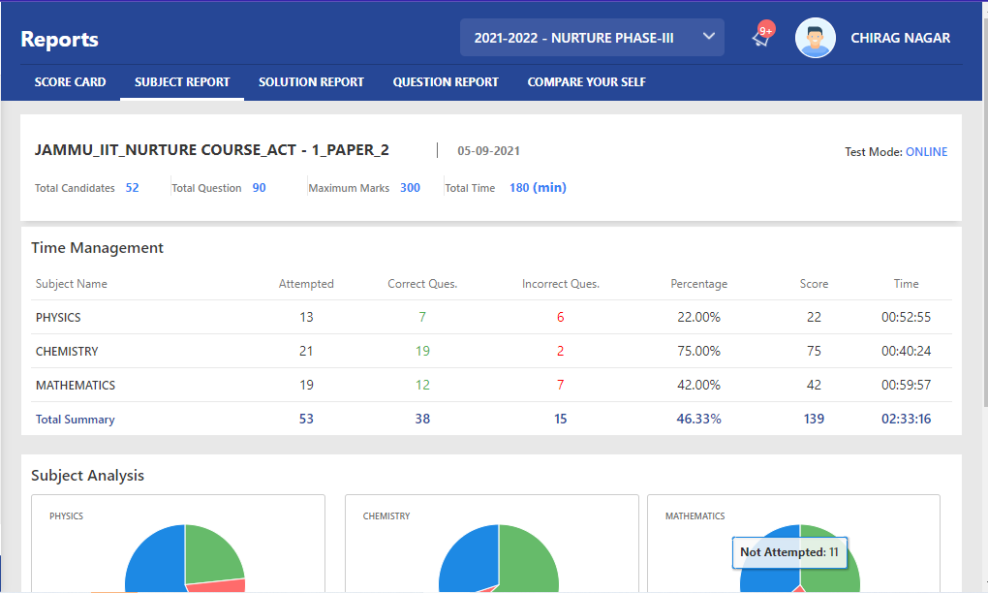

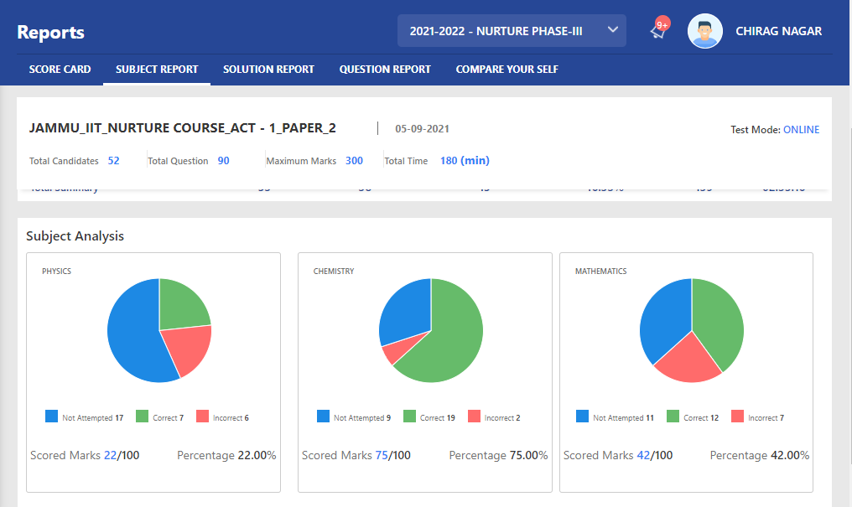

**Solution report**

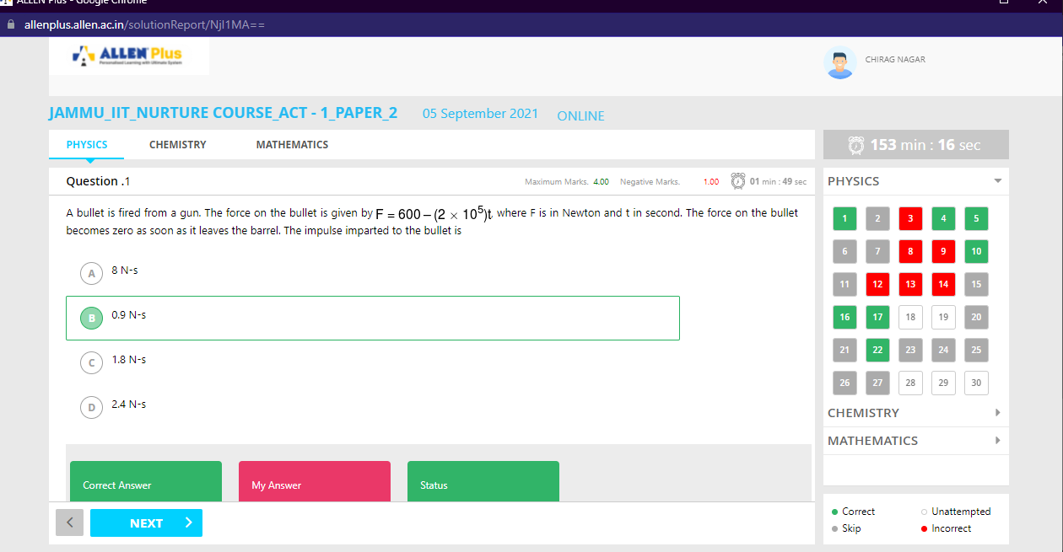

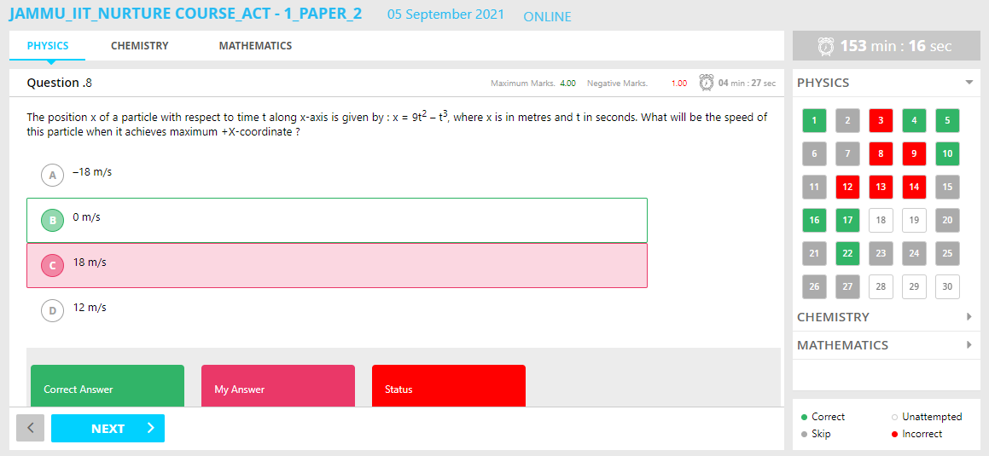

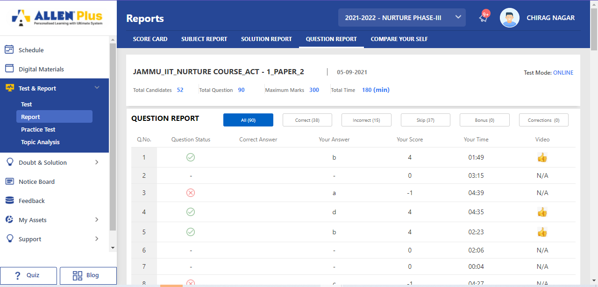

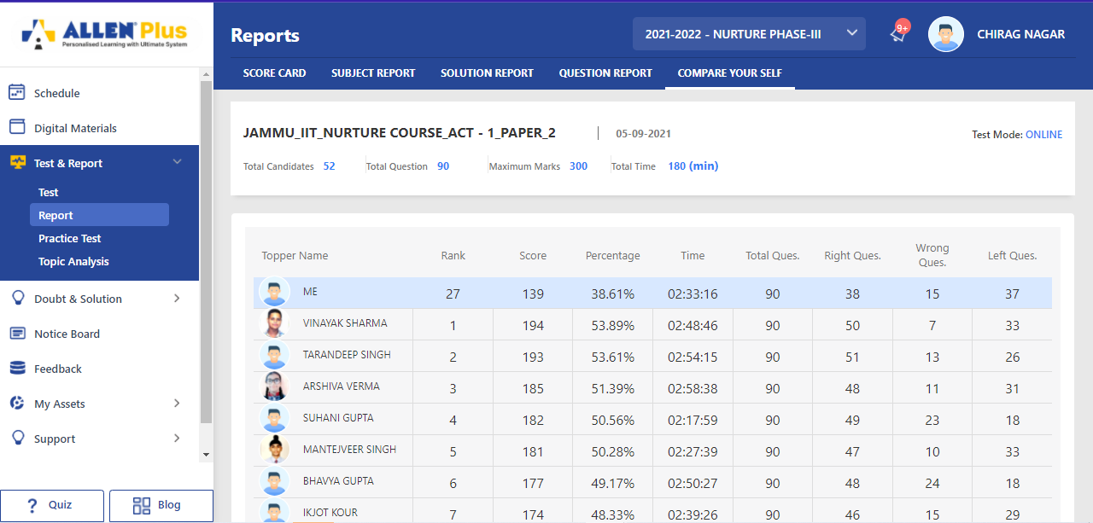

|  |  |  |  |
| --- | --- | --- | --- |
| New Table |  |  |  |
| Submitted Idea |  |  |  |
| Submitted Idea Report |  |  |  |
|  |  |  |  |

|  |  |  |  |
| --- | --- | --- | --- |
| New Table |  |  |  |
| Attendance record of student |  |  | Attendance record of student & send this to parents on their unavailability & weekly, monthly report to parents |
|  |  |  |  |
|  |  |  |  |

|  |  |  |  |
| --- | --- | --- | --- |
| New Table |  |  |  |
| Doubt & Solutions |  |  |  |
| Filter system |  |  |  |
| Ask Doubt |  |  | Type  Write on white board  Pdf  image  video  audio |
| Already asked doubt solutions |  |  |  |
| Book session |  |  |  |
| Un resolved |  |  |  |
| Resolved |  |  |  |
| Others asked doubt 🡪 filter system of topics subjects |  |  |  |
| Unresolved with solution |  |  |  |
| View solution |  |  | Type  Write on white board  Pdf  image  video  audio |
| Material solution |  |  |  |

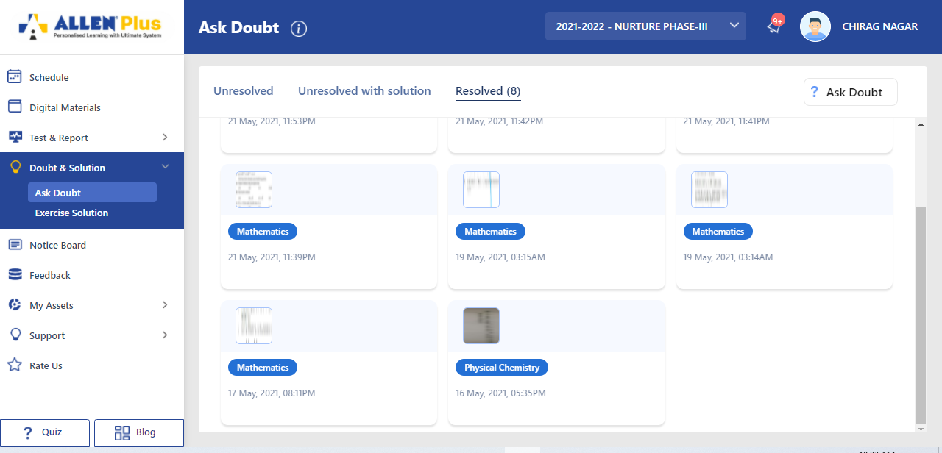

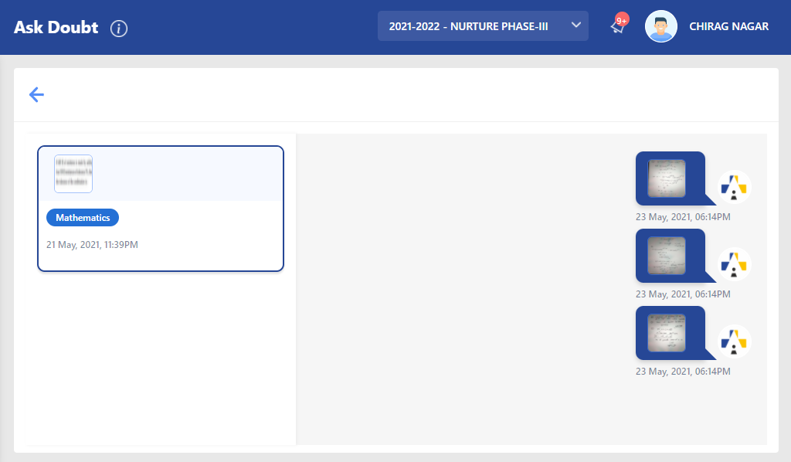

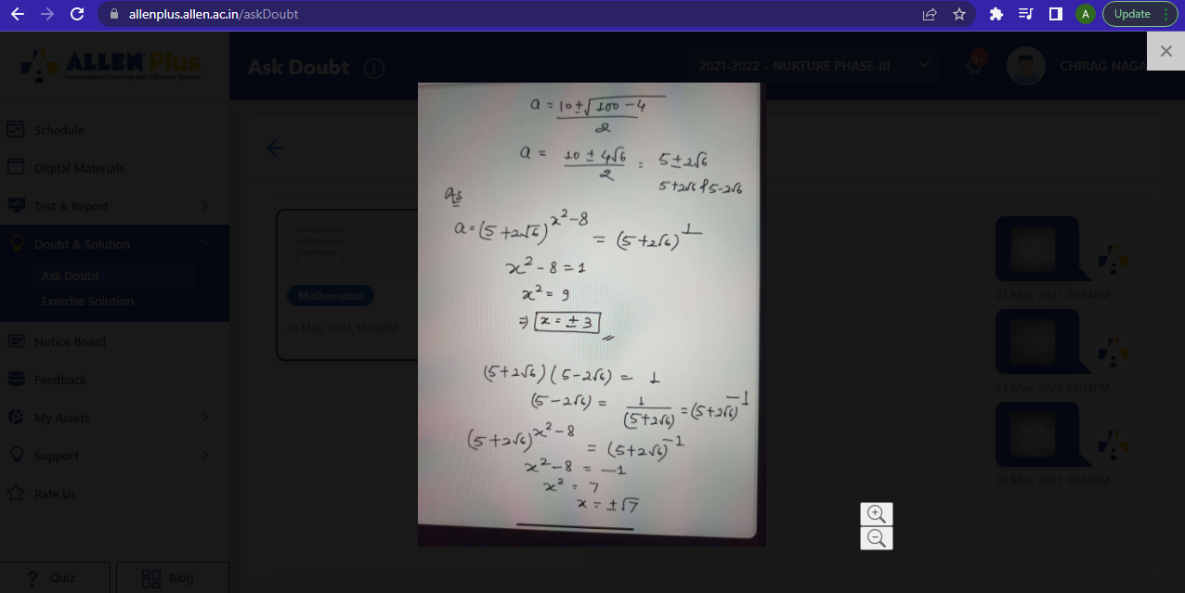

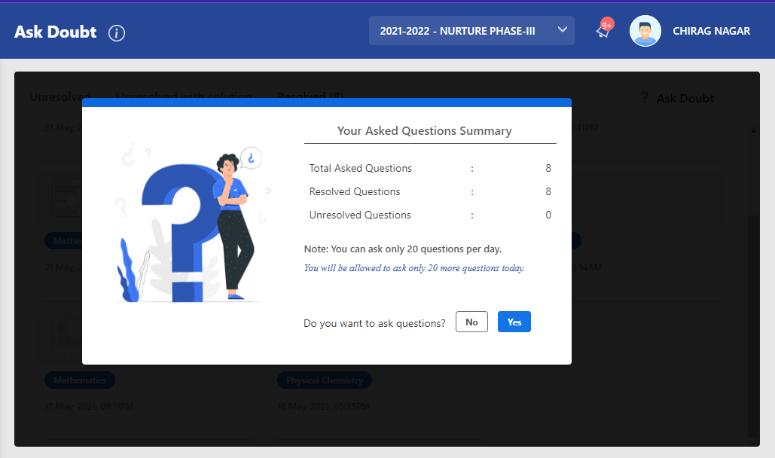

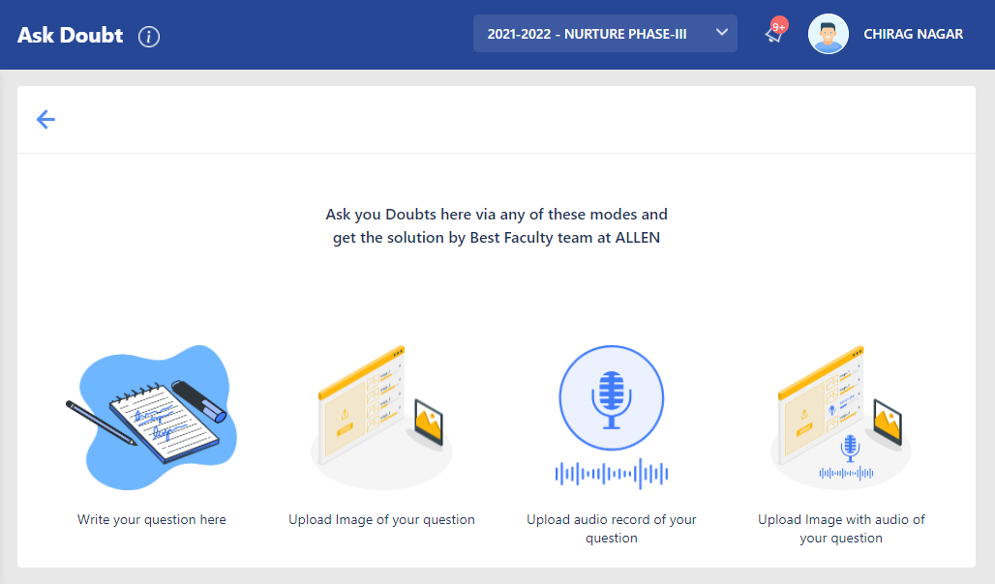

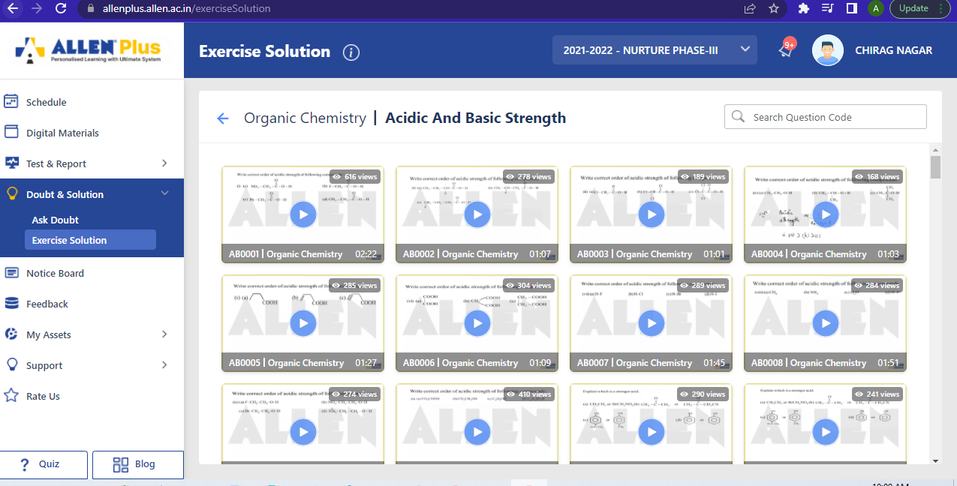

**Self notes**

|  |  |  |  |
| --- | --- | --- | --- |
| **Notes** |  |  |  |
| **Home work** |  |  |  |
|  |  |  |  |
|  |  |  |  |

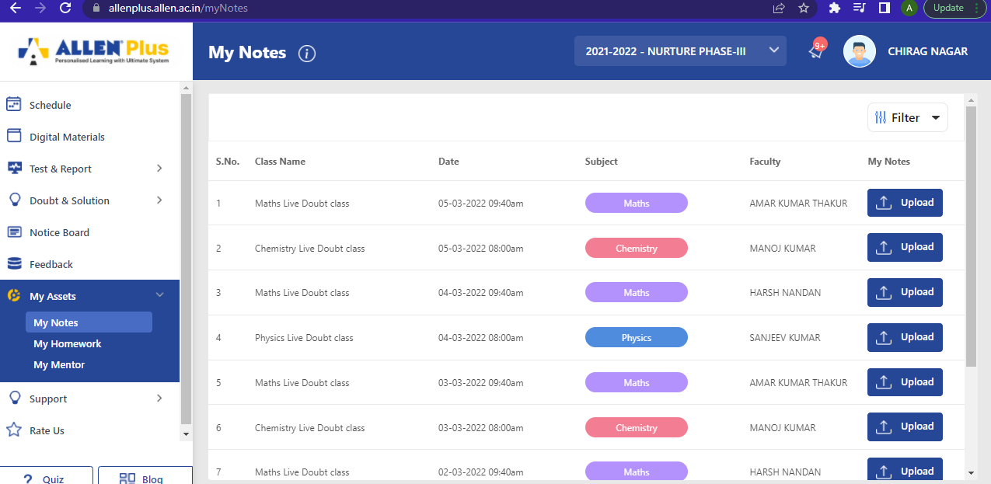

|  |  |  |  |
| --- | --- | --- | --- |
| **Mentor** |  |  |  |
|  |  |  |  |
|  |  |  |  |
|  |  |  |  |
|  |  |  |  |

|  |  |  |  |
| --- | --- | --- | --- |
| Quiz |  |  |  |
| Live quiz |  |  |  |
| Self practice quiz |  |  |  |
| Scholarship quiz |  |  |  |
|  |  |  |  |

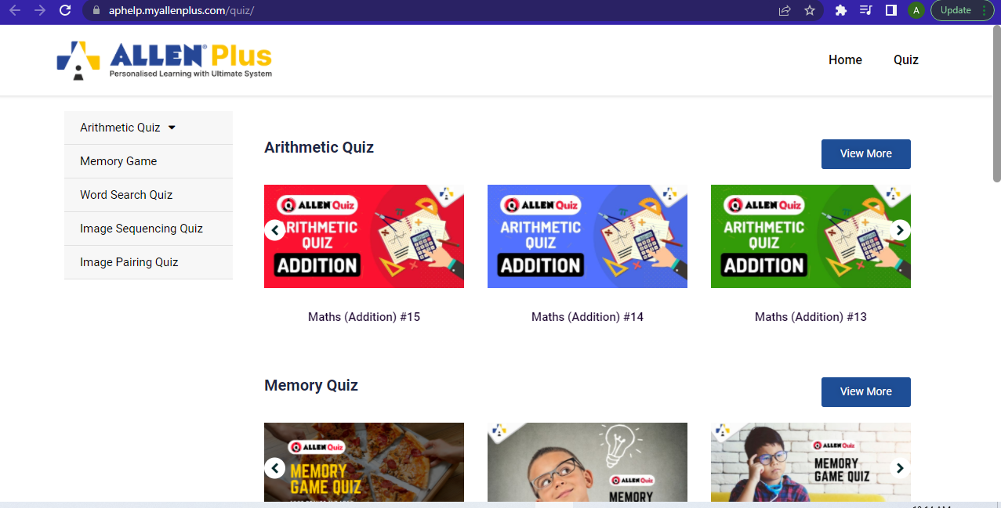

|  |  |  |  |
| --- | --- | --- | --- |
| New |  |  |  |
| Notice board |  |  |  |
| Upcoming events |  |  |  |
| Bootcamp |  |  | See & register |
| Course launch |  |  | Give an update  See & register |
| News letter |  |  |  |
| New thing on our platform |  |  |  |
| Field release |  |  |  |
| Test |  |  |  |
| Quiz |  |  |  |
| Hakathon |  |  |  |
| Festival 1-3 days event ideas |  |  |  |

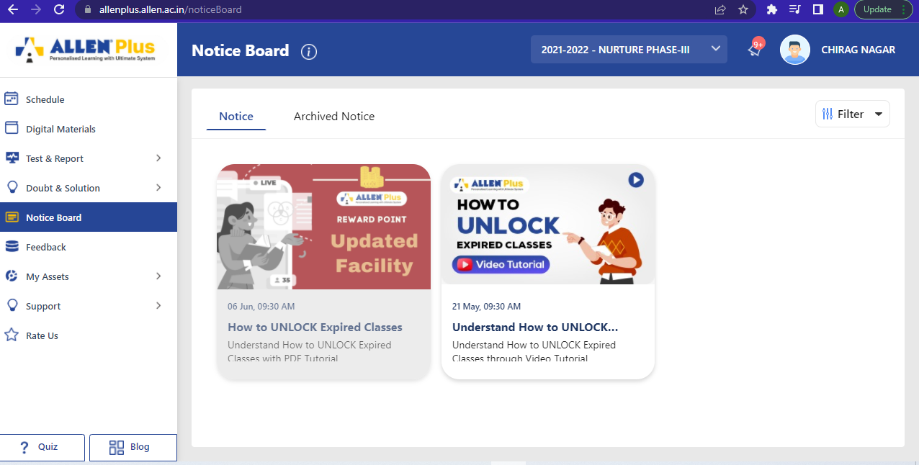

|  |  |  |  |
| --- | --- | --- | --- |
| **My Points** | | | |
| **Field Name** | **Mandatory?** | **Data Type** | **Description** |
| My points | N | Number count | Will consist of the points on attempting test and other activities for which points are assigned by the admin.   * Quiz * Daily videos seeing * Streax * 1 week allocated activity complete point |
| Wallet | N | Number count | Will consist of the total points redeemed into the wallet |
| Streax maintain |  | Select target | Streax completed if target achieved then we provide reward / points |

**Example link of streaks:** <https://www.interviewbit.com/problems>

|  |  |  |  |
| --- | --- | --- | --- |
| **My Test** | | | |
| **Field Name** | **Mandatory?** | **Data Type** | **Description** |
| Subject name | N | Read only | Will consist of the subject name for which we are attempting the test. |
| Time | N | Time limit | Will consist of the timer running for the test |
| Submit | Y | Button | Allows user to submit the test. |
| Back | N | Button | Allow user to go back to the previous screen |
| Next | N | Button | Allows users to move to the next screen. |

|  |  |  |  |
| --- | --- | --- | --- |
| **Doubt Session** | | | |
| **Field Name** | **Mandatory?** | **Data Type** | **Description** |
| Live with the mentor | N | Live session | Will be the live session with the mentor and student for doubt clearance. |
| Comment | N | Comment box | Allows users to comment their doubts during the class. |
| End call | N | Button | Allows user to end the call. |

|  |  |  |  |
| --- | --- | --- | --- |
| **Subject and chapters** | | | |
| **Field Name** | **Mandatory?** | **Data Type** | **Description** |
| Subject name  Total chapters | N | Header | Will showcase the name of the selected subject and total no of chapters of it. |
| Chapters | N | Chapters listing | Allows users view the chapter listing for that particular subject. |
| Topics | N | Topics listing | Allows user to view the topics of the chapters |
| Videos | N | Video listing | Allows users to view video of a particular topics. |
| E books | N | EBook listing | Allows users to view and read eBooks of the subscribed subject |

|  |  |  |  |
| --- | --- | --- | --- |
| **Digital Material** | | | |
| **Field Name** | **Mandatory?** | **Data Type** | **Description** |
| Pdf viewer |  |  |  |
| Pdf editor |  |  |  |
| Study Material |  |  |  |
| Race |  |  |  |
| Sat |  |  |  |
| Exercise |  |  |  |
| Sheet |  |  |  |
| Short Notes |  |  |  |
| Booklet |  |  |  |
| Class Notes |  |  |  |
| Step 1 |  |  |  |
| Step 2 |  |  |  |
| Step 3 |  |  |  |
| Step 4 |  |  |  |
| Filter system |  |  | Datewise  Subject wise  Chapter  Course  Class |
|  |  |  |  |

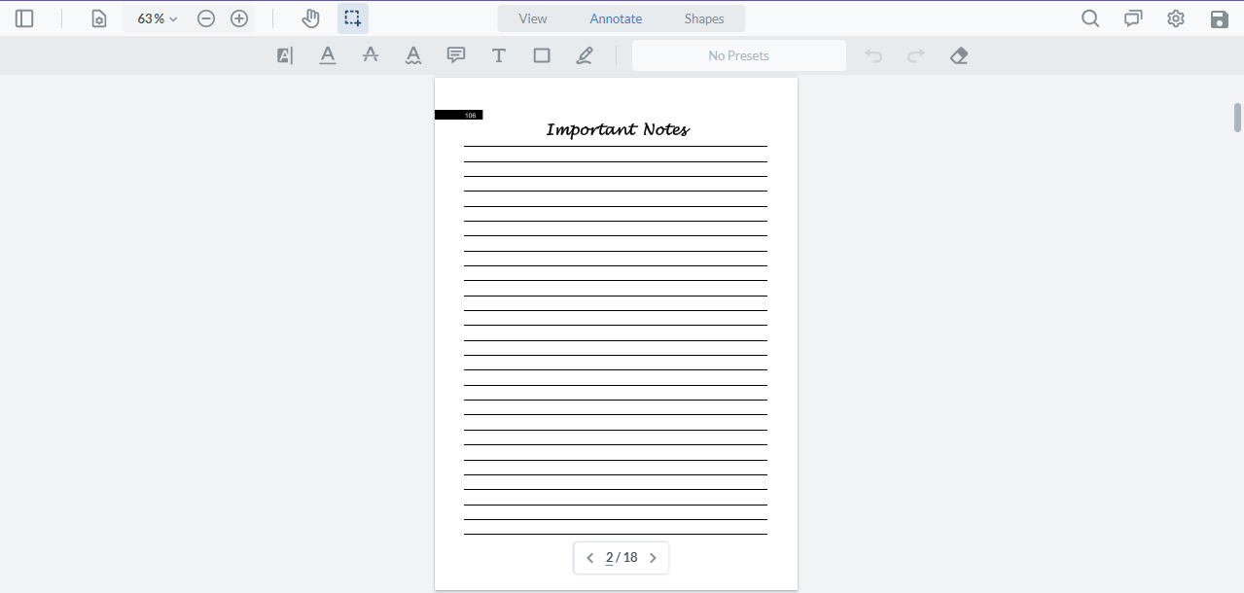

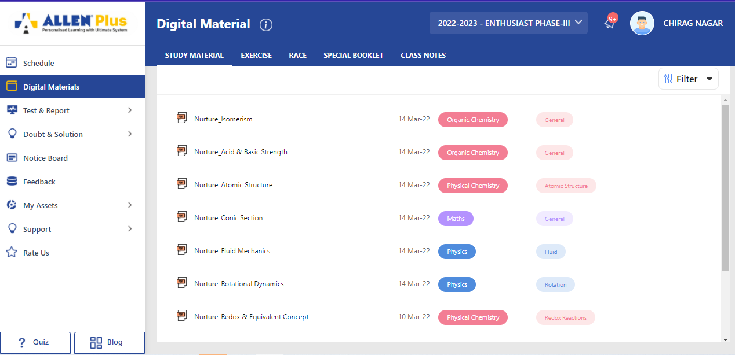

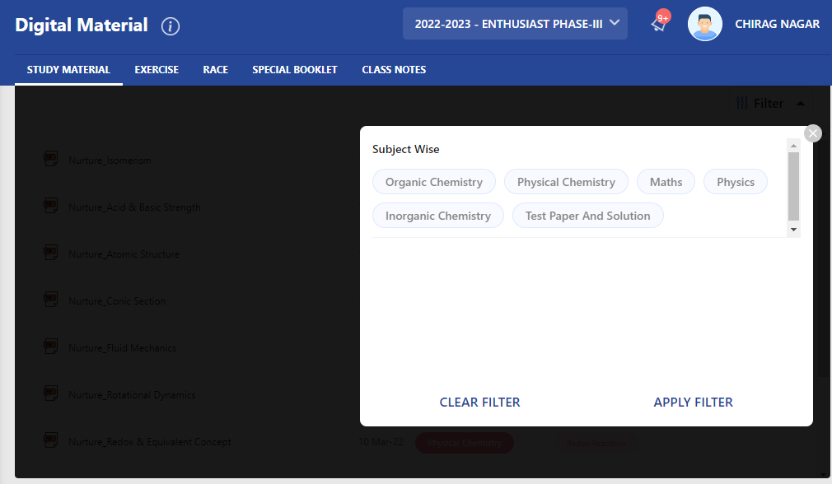

|  |  |  |  |
| --- | --- | --- | --- |
| **Buy a course** | | | |
| **Field Name** | **Mandatory?** | **Data Type** | **Description** |
| Name of course | N | Text box | Will showcase the name of the selected course. |
| Chapters | N | Chapters listing | Allows users view the chapter listing for that particular subject. |
| Topics | N | Topics listing | Allows user to view the topics of the chapters |
| Videos | N | Video listing | Allows users to view video of a particular topics. |
| E books | N | EBook listing | Allows users to view and read eBooks of the subscribed subject |
| Plans | N | pricings | Allows users to view pricing of the courses |
| Validity | N | Time validity | Allow users to know the price validity of the course |
| Buy now | N | Button | Allows users to pay for the course by redirecting it to payment gateway. |
| Listing of courses, books, notes, assignments, subscriptions etc on ecommerce platform |  |  |  |

|  |  |  |  |
| --- | --- | --- | --- |
| **Student forum** | | | |
| **Field Name** | **Mandatory?** | **Data Type** | **Description** |
| Post | N | Text box | Allows users to post into the forum, only when student logged in and post is approved by the admin |
| Use Hashtag according to topic/subject of post |  |  | Tagging of topic |
| Read | N | Read only text | Allows users to read the forum post |
| Comment | N | Input box | Allows users to comment on other users’ post. |
| Report or block any unfitted comment or post | N |  | Allows users to Report or block any comment or post |
| Share post | N | icon | Allows users to share post on any other platform and also allows them to share the link also. |
| Tag | N |  | Allows users to Tag any friend or (mentor or expert by admin permission) |

|  |  |  |  |
| --- | --- | --- | --- |
| **Student Assignment** | | | |
| **Field Name** | **Mandatory?** | **Data Type** | **Description** |
| View assignment | N | Button | Allows users to view their assignment. |
| Assignment listing | N | Tab (completed /not completed) | Allows users view their completed and not completed assignment |
| Upload assignment | N | Upload attachment | Allows users to upload their attachment in pdf format. |
| View remarks on assignment | N | Teachers comment | Allows users to view the teacher’s remark on the assignment. |

|  |  |  |  |
| --- | --- | --- | --- |
| **Community** | | | |
| Community Name | **N** | Menu | Will Consist of all the community listed from the admin panel. |
| Community Detail | **N** | Read only text | Will consist of detail of the Community. |
| Community Listing | **N** | Menu | Will Consist the list of all the community added from the admin Panel. |
| Join Community | **N** | Button | Enable users to join that particular community. |

|  |  |  |  |
| --- | --- | --- | --- |
| **Student profile** | | | |
| **Field Name** | **Mandatory?** | **Data Type** | **Description** |
| Edit profile | N | Menu | Allows users to edit their personal info. |
| My courses | N | Redirect to my course page | Allows users view their subscribed courses. |
| My community | N | Community page | Allows users view their community. |
| My points and wallet | N | Wallet page | Allows users to view their points and wallet |
| My recorded video | N | Video page | Allows users to view all their recorded video (will be deleted after a period of time) if want to retrieve user will send a request to admin for retrieval. |
| My tutors | N | Tutors page | Allows users to view their tutor’s details for various subject. |
| Book consultant | N | Booking page | Allows users to book for consultancy according to the slots available. |